# **LITTERING**

Littering is one of the biggest problem we face in the community that I live in.

There is litter everywhere in the streets and people hope that the government is going to do something to clear it but little has been done currently. They only hired people to clean the streets but they cannot tackle the piles of litter that are in the streets.

It is worrying and it has to be removed because it is a health hazard to us people who live in this environment so I reckon that the best way to deal with it is by using machines.

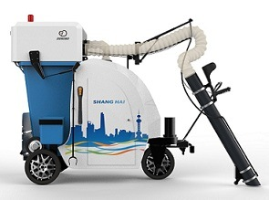

A ***VACUUM CLEANER*** that would be able to take in all the litter would be the best solution for this problem. It will be quicker and easier as it will be able to take in any form of litter including plastic, cans, glass etc.

The vacuum could be taken to the street and once it gets activated it should start sucking in the litter which it should be able to recognise. It can have sensor of whether or not there is an obstacle on it’s path and direct it’s self of where to go and look for litter everywhere.

We can use all this litter to make other products, maybe even use the waste to give our land minerals by using the waste materials for farming. It is not safe to reuse the materials but most of them can be cleaned and recycled which is profitable in most circumstances.

People must also be prevented from Littering so that our streets can be cleaned and there are ways in which we can stop them from littering.

Posting “Stop Littering” signs and raising awareness of the dangers of littering is the best basic way of stopping people from littering.